(Approx. 1140 words)

Desktop Publishing
By Dick Maybach, Brookdale Computer User Group
www.bcug.com
n2nd (at) att.net
Modern word processors have extensive formatting capabilities, but if you produce posters, newsletters, or brochures, you may need a competent desktop publishing program such as Scribus, https://www.scribus.net/. You begin with the text, created by a word processor, and graphics, created by a graphics program, and use the desktop publisher to organize them into a poster, leaflet, or newsletter. Scribus is open source and free; you can easily experiment with it to see if it fits your needs. Regardless of your desktop publishing software, you will still need a good word processor for its spelling, grammar, style checking, and graphics programs to generate artwork and edit images. A desktop publisher is strictly for layout; it provides little help in developing content.

Desktop publishing is a complex process, and learning to do it well requires considerable effort. So here, I'll only introduce Scribus to help you decide if you need such a tool. The first example is a poster, shown in Figure 1; the detailed directions are in the Scribus Quick Start Guide section of its help document or at https://wiki.scribus.net/canvas/Help:Manual_Quickstart.

Figure 1. Scribus Poster.

Figure 2 shows the Scribus window for the same poster. Note the black rectangles, called "frames," that enclose its elements. Selecting one will highlight it and allow you to make changes, for example editing its content, adjusting its size, or moving it. Each frame also has a level. Here the lowest level frame is the gray background, and the next higher is the portrait. As a result, the portrait hides the portion of the background that it covers.

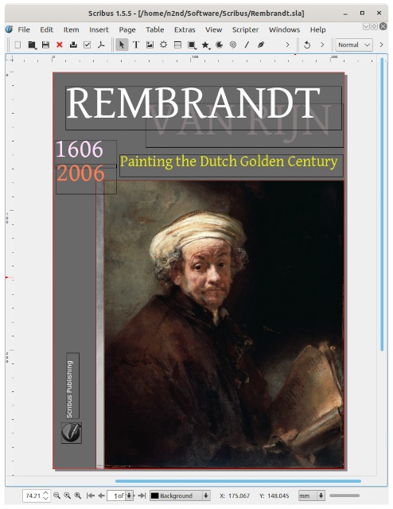
Figure 2. Scribus Window for the Poster.

Learning to use Scribus can be challenging since you must unlearn some word-processor habits you've used for years. If you look carefully at the menu bars, you'll see that they resemble those of an image processor, such as GIMP, more closely than those of a word processor, such as LibreOffice. This isn't surprising, given the tasks performed by a desktop publisher. It takes text and images created by other tools, modifies their properties (sizes, fonts, colors), and places them on a canvas.

Many tools are accessed from auxiliary windows such as the one shown in Figure 3, which shows the frame's properties that contain "Painting the Dutch Golden Century." Frames can be sized and placed by dragging, but it's more accurate, if slower, to enter the numbers in the property window, where you can also define other attributes.

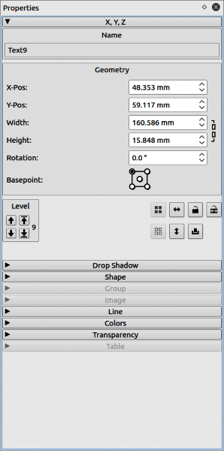
Figure 3. Properties of the "Painting the Dutch Golden Century" Frame.

Scribus has a simple text editor called a story editor, Figure 4, with similar but simpler tools as in your word processor. However, it's not quite WYSIWYG, as text effects don't appear in the editor window but only on the main display. You will import most text from a word processor document and use the story editor only for very short items, such as titles.

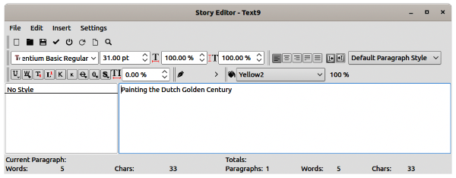
Figure 4. Scribus Text Editor.

This poster could also have been created with a photo editor, such as GIMP. You would probably crop and touch up the image as a first step, and adding some text using the same tool wouldn't be difficult. Someone familiar with both tools would probably find it easier to use a desktop publishing program for the latter, but you could obtain comparable results using only GIMP.

Our following example is a brochure, described at http://archive.flossmanuals.net/_booki/scribus-2/scribus-2.pdf. Again, this is a single sheet, printed on the front and back, and folded into thirds, so that you see a cover with a title and a graphic, which you open to see three columns of text, with a fourth on the back, Figure 5.

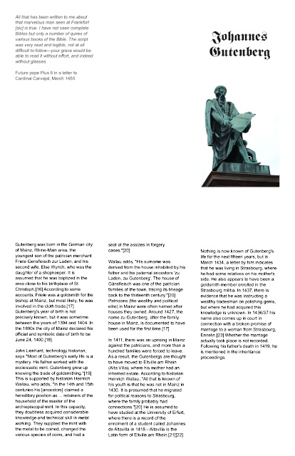
Figure 5. Brochure.

Figure 6 shows Scribus with the brochure open. Note the arrows linking the text frames, which means that the overflow continues in the next frame when a window fills.
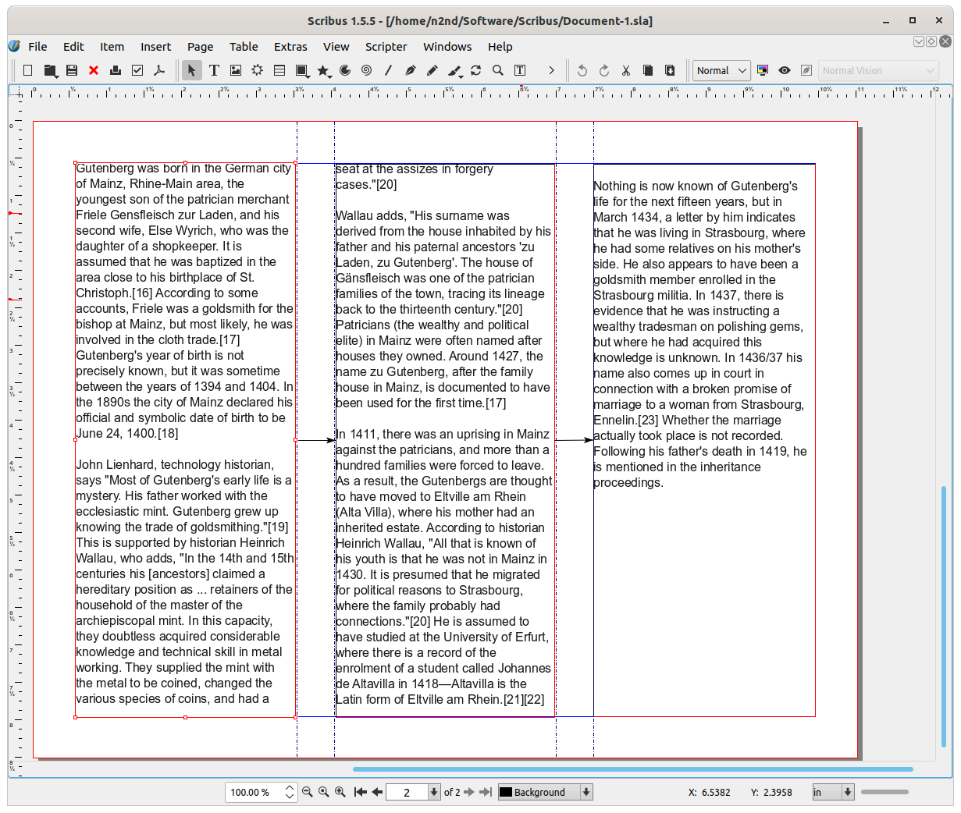
Figure 6. Scribus Editing a Brochure.

You could create this using a capable word processor, such as LibreOffice, although formatting the pages would be a bit tricky. Someone comfortable with both programs would probably choose to format the brochure using desktop publishing.

The above two examples could have been developed using an image and a word processor. However, let's now look at one that requires desktop publishing, described at https://wiki.scribus.net/canvas/Get_Started_with_Scribus. This is a six-page brochure with a complex mix of images, text, and graphics, Figure 7.

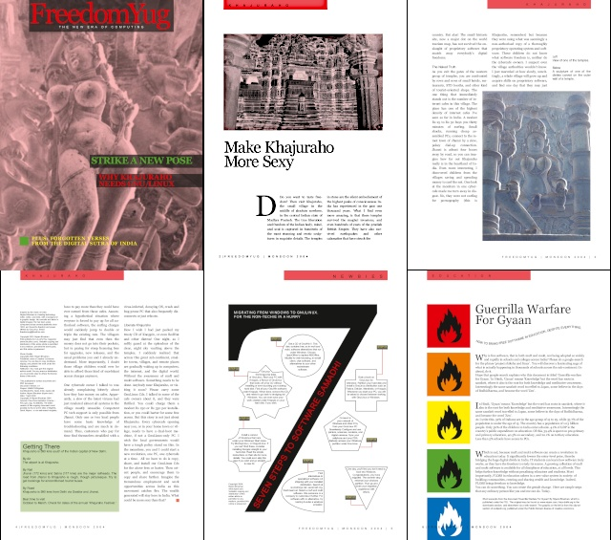
Figure 7. Six-page Brochure.

Figure 8 shows the Scribus view of page 4, which has several text boxes. Note the arrow coming into the two-column box on the right, showing its text continued from a previous page. The page header is a text box overlaying a second one filled with red. The lower left box forces the one on its right to wrap around it. It uses different styles than the others. The upper left box also has its own style. The page could be formatted with a word processor, but it's much easier with desktop publishing.

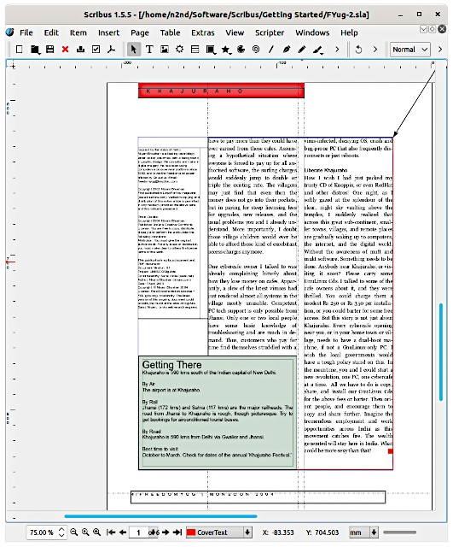
Figure 8. Brochure, Page Four.

The "Getting There" box at the bottom left illustrates another difference between Scribus and a word processor. Text in a Scribus text box has no margin space. So this is really two boxes, a rectangle with a tinted background and a slightly smaller text box to set the margins. The same technique was used on page three to set the white space around the graphic at the bottom right, which a slightly larger box behind it to create some space.

Creating the page of Figure 9 with either an image or a word processor would be very tedious. Of course, it was developed more to show some desktop publishing capabilities than to communicate effectively. Actually, constructing this is simple. There is a single large graphic, a number seven, with some rectangular text boxes layered on top of it, plus a number of text boxes with various shapes, connected by red lines, and finally, the header and footer. This page's layout is different from the others, and it has a separate template.
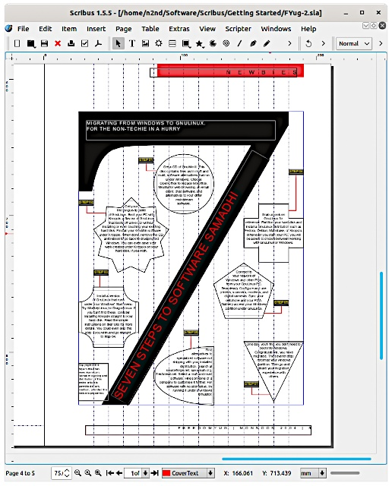
Figure 9. Brochure, Page Five.

Like most desktop publishing software, Scribus is complex and requires learning time and effort. In this short article, I can only introduce it enough to help you to decide if it's worth your time to investigate. The program is available from the website listed at the beginning of this article. Be sure you get the stable version, currently 1.4.8, as it will best match the available documentation. (The examples in this article used 1.5.5, a development version, which added some adventure to its writing.) Working through the three examples above will get you started, provided you download the source material and create the documents. Stay flexible, as most tutorials are fairly old, and you will find some differences between them and the current program.

